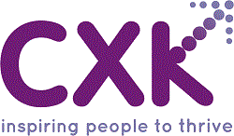

ESF Community Grants Programme
Grant recipients quarterly reporting dates to CXK
 | Quarter Dates  Start Finish | Grant Recipient Deadlines
2019/ 20  Q1  Q2  Q3  Q4 | 01/04/2019 30/06/2019  01/07/2019 30/09/2019  01/10/2019 31/12/2019  01/01/2020 31/03/2020 | 5th working day of the following month at the quarter end
2020 / 21  Q1  Q2  Q3  Q4 | 01/04/2020 30/06/2020  01/07/2020 30/09/2020  01/10/2020 31/12/2020  01/01/2021 31/03/2021 | 5th working day of the following month at the quarter end
2021 / 22  Q1  Q2 | 01/04/2021 30/06/2021  01/07/2021 30/09/2021 | 5th working day of the following month at the quarter end

At the end of each quarter each grant recipient must submit the following information for monitoring and compliance purposes:
- A Progress Report in the agreed format covering any activity in the previous quarter
- An up to date list of staff working on the project
- One case study

At the end of the project all hard copies of paperwork will need to be sent to CXK. It will also be required during the time of the contract should an audit take place on CXK.

