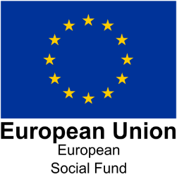
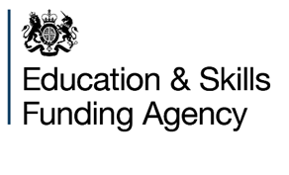

ESF Case Studies and Good News Stories

Case studies and good news stories are an effective way of encapsulating how individuals and business are being supported by the European Social Fund (ESF) and the impact this is having. It is an opportunity for participants to explain how the training and support they received has helped them to overcome their own personal barriers and enabled them to enhance and extend their employment opportunities or move them towards the labour market.
Project case studies are also a way for lead providers to promote the work they have been doing and in some instances share good practice.
Four case study templates have been developed to enable providers to share the achievements of individuals, business and projects that have been supported by ESF.

Template | Investment Priority
EMPLOYER | 2.1
PARTICIPANT | 1.1, 1.2, 1.4, 2.1
PROJECT | 1.1, 1.2, 2.1
COMMUNITY GRANTS | 1.4

General points to take into consideration
- ESF 2014-20 Funding Rules V1 May 19: Paragraph 142 Reporting and Evidence - You are required to hold and retain the following: Publicity material, case studies and good news stories.

- Case studies must be submitted on the templates provided

- All sections, including the ESF contract number, must be completed in the boxes provided – if the template is being completed by a sub -contractor/business /participant these can be completed by the lead provider prior to submission

- Case studies and good new stories may originate from lead providers, sub-contractors or some other source but they should always be approved by the lead provider before being submitted to the Agency

- Quality not quantity – we received approximately 250 case studies in the first half of the programme but were unable to use many of these as the quality was poor and did not contain enough information to be informative or they were hand written and illegible. The bullet points in each section of the template should inform the writer of the areas we are interested in hearing about.

- The starting point/background of the participant/business is just as important as the achievement as it demonstrates the learner journey and shows any barriers that the participant has had to overcome.

- The templates are not prescriptive and some points may not be relevant to the type of programme the provider is delivering, they are meant as a guide.

- If providers are not able to complete all the sections in the template the ESFA are still interested in hearing from them - just ensure they have included as much relevant information as possible.

- If your case study relates to individuals please ensure that the participants have included a consent form.

- Case studies should checked by M&D Advisors and sent to Michelle Channing in the ESF Programme Team

Further information regarding ESF Case Studies can be found here:
https://www.gov.uk/government/publications/european-structural-and-investment-funds-case-studies

