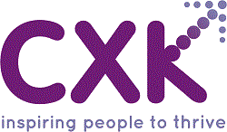
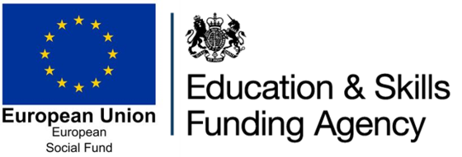
ESF Community Grants Programme
Quarterly progress report for grant recipients to complete

Organisation Name:

Project title:

Reporting period | Q1 April – June / Q2 July – Sept / Q3 Oct – Dec / Q4 Jan - March
 | Please highlight the quarter you are reporting against

Part One: About your project
What progress have you made?
Describe the main activities you’ve started, continued or finished during this reporting period. Write up to 300 words.

What have you learned?
Tell us about any achievements or unexpected outcomes you’d like to share with us along with any problems you’ve faced and how you’ve tackled them.
Write up to 300 words.

Part Two: Your project outcomes
With reference to the targets and outcomes described in your application and included in your grant agreement, please outline
- your progress towards each of the project outcomes
- any milestones you’ve achieved
- any changes you may need to make to your project and why.
Write up to 300 words.

Part Three: Publicity
It is a condition of the grant that you acknowledge the European Social Fund on any correspondence or materials used for the delivery of the project. This includes: job descriptions, promotional materials, event materials, paperwork and websites.
Provide a list or description of the publicity you have carried out. Write up to 300 words.

Please return by uploading to your SharePoint folder by the agreed dates.

